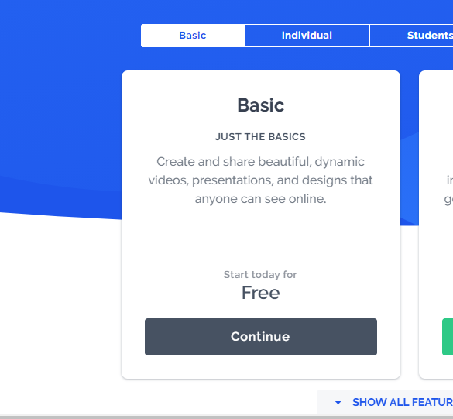
Creating a Prezi Account
1: Visit the following website
https://prezi.com/pricing/basic/

2: Click the Continue bottom under “Free”

3: Sign up using your name and email
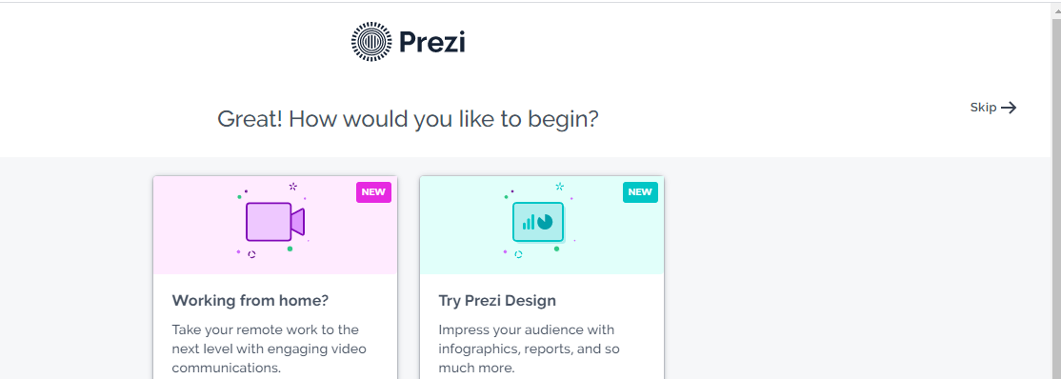
Email:
Password:

4: Click Skip in the top right-hand corner

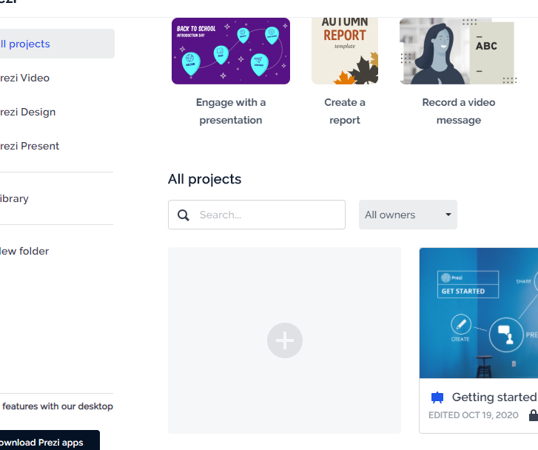
5: Click the blank template with the + sign

6: Choose a template you will use for the rest of the week.

