How to Utilize the “Snipping Tool”

Step 1: Find the magnifying glass in the bottom left of your screen

Step 2: Type “snipping tool” and select the application
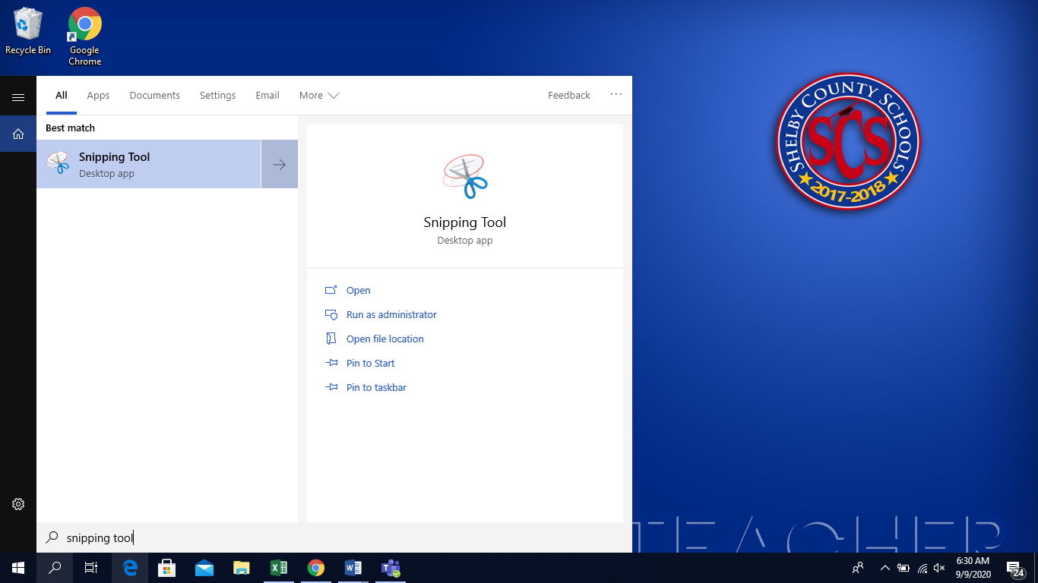

Step 3: Click New
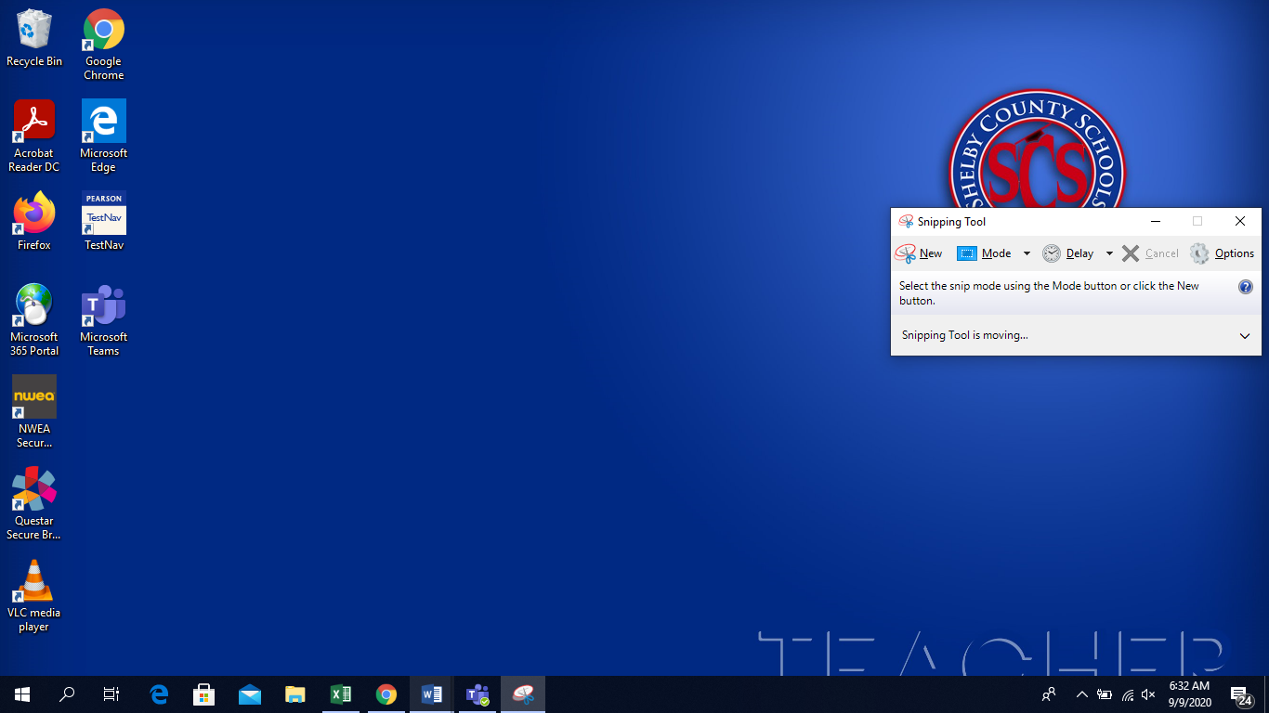

Step 4: Use the + to drag or surround what you want to copy/snip
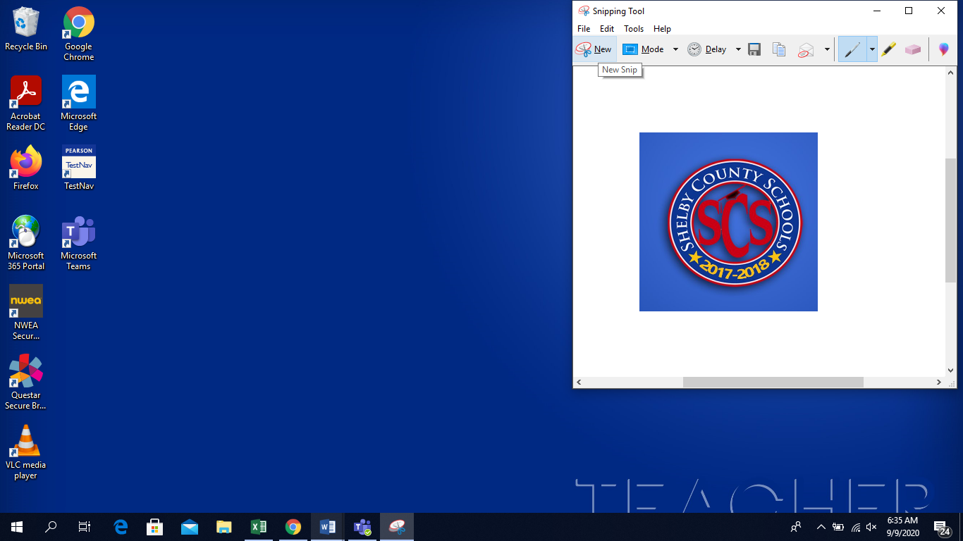

Step 5: Click the copy or save button to add to your computer or document
