John Marshall
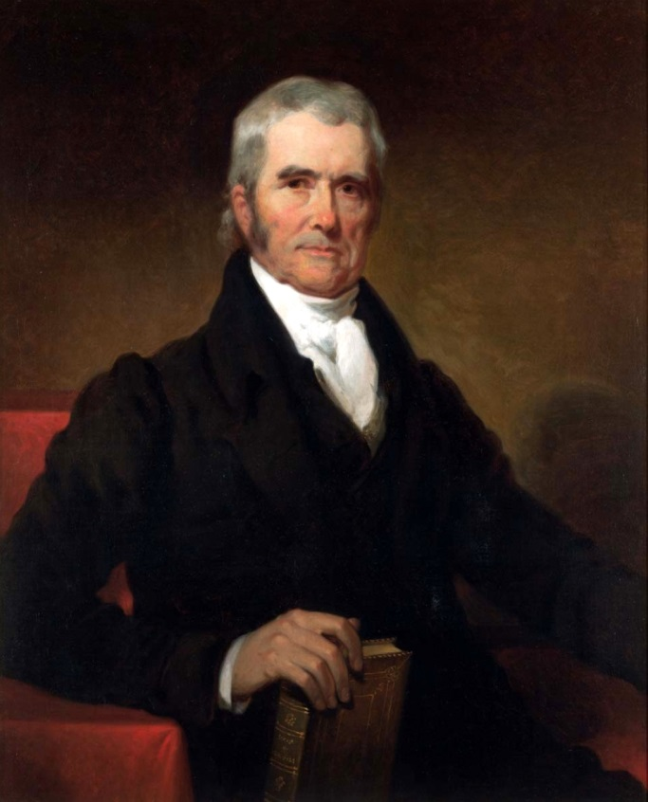

NAME:
THREE CHARACTERISTICS:
RELATED TO:
WHO CARES DEEPLY ABOUT:
WHO FEELS:
WHO NEEDS:
WHO GIVES:
WHO FEARS:
WHO WOULD LIKE TO SEE:
RESIDENT OF:

John Marshall
b. September 24, 1755, Germantown, VA
d. July 6, 1835, Philadelphia, PA
Fourth Chief Justice of the Supreme Court
(1801-1835)
John Marshall's legal career began in 1780 when he took a six-week lecture course at William & Mary College. This was to be Marshall's only formal legal training, though he went on to become the greatest and longest-serving chief justice in the history of the Supreme Court, hearing more than 1,000 cases and writing 519 decisions.
Licensed to practice law in Virginia in August 1780, he was elected to the Virginia House of Delegates in 1782 and 1784. He established a private law practice in Richmond and served as a delegate to the Virginia convention established to ratify or reject the newly framed Constitution. His arguments in favor of the new federal system were instrumental in persuading that body to ratify the document in 1788. He became a leader of the Federalist Party in Virginia in the 1790s. He turned down an offer to serve as Attorney General of the United States in 1795 but accepted appointment in 1797 to a three-member commission sent to France to improve relations between the two nations. When French officials snubbed the commission and asked for a bribe, Marshall formulated the American refusal. For this he became immediately popular in America and was often, and wrongly, credited with the slogan "Millions for defense, but not one cent for tribute."
President John Adams appointed Marshall to the Supreme Court in early 1801. On assuming his duties on March 5, Marshall took immediate action to strengthen the power of the Court. Thomas Jefferson was coming into office as president, and his party dominated Congress. Because Jefferson's party opposed central federal powers, Marshall feared his Court could be ignored and marginalized. He persuaded the justices to support a single majority opinion in all cases to make the voice of the Court more authoritative. In Marbury v. Madison (1803), the unanimous Court, in a decision devised and written by Marshall, overturned an act of Congress for the very first time, on the grounds that it conflicted with the Constitution. It was a daring step for the politically vulnerable Court, but Marshall crafted the opinion in such a way that even Jefferson could not reject it. What resulted was a founding principle of American political life: the Constitution is a set of laws that the courts may interpret, and the Supreme Court may declare null and void any new law that conflicts with the "laws" of the Constitution. This has become known as Judicial Review. Marshall would never again void a federal law, but the series of forceful, well-argued decisions issued by his Court over the following years created a unified body of constitutional doctrine and established basic principles of federal power that have survived to the present day.
A modest -- even bland -- man in most ways, Marshall was strong in his views. He dominated the Court from 1801-1835 and was personally responsible for elevating it to a position of real authority. While holding court, he would become jovial with his counter-parts, often enjoying glasses of wine together. Marshall has been even recorded as buying wine by the pipe or 1,000 pints at a time. In his later years he increasingly shared power with his fellow justices and often curbed his opinions in order to arrive at consensus decisions. He never relinquished his leadership, however, and he established the model against which all future chief justices would be measured.

