President Fujimori of Peru

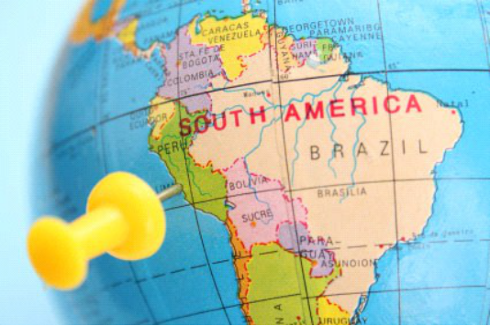Peru is a large country in South America. Like the United States, Peru has a constitution. Peru’s constitution created a government that had a President, a Congress, and
a judicial system.

In 1990, a man named Alberto Fujimori became president of Peru. The first thing Fujimori wanted to
do was solve the huge financial problems Peru had been having. Fujimori had some ideas for laws he thought would solve the problems, but Peru’s Congress would not pass the laws he suggested. This made Fujimori unhappy, so he decided to take matters into his own hands.

On the night of April 5, 1992, Fujimori came on television and said he
was “temporarily dissolving” Congress in Peru. He also said he was going to “reorganize” Peru’s judicial branch.

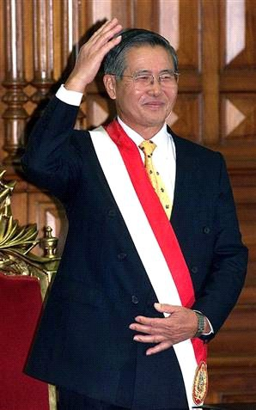

Fujimori after his election in 1990

President

Peru’s
Constitution
☞ Look at the diagram of Peru’s government. Do you think Fujimori had the power to do away with Congress and “reorganize” the judicial branch?

Because the President did not have the power to make these changes, Fujimori had to use force in order to change Peru’s government. He used military tanks and tear gas to keep Congress from meeting. He arrested people who disagreed with him, and he also arrested popular journalists and businessmen. Just to be safe, he even arrested the man who had been
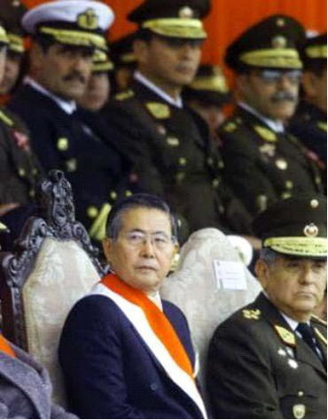president before him!

Of course, all of this was illegal under Peru’s constitution. To take care of this problem, Fujimori issued a decree that said Peru’s Constitution could be ignored. (A decree is like a law issued by a president.) Fujimori’s decree also got rid of Congress and gave the president (himself) all the power to make laws. Fujimori then fired almost half of Peru’s 23 Supreme Court justices, as well as many other judges around Peru who believed his actions were unconstitutional. In other words, Fujimori took total control of Peru’s government.

Fujimori with his military leaders

President Fujimori of Peru (cont.)

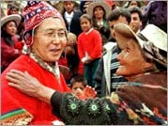

Fujimori with a supporter in traditional Peruvian clothing
Fujimori’s control led to some accomplishments. He solved the economic crisis and successfully fought a group of terrorists that had taken control of several regions of the country. Just when things looked so good, however, people began to learn about other things Fujimori was doing. Because he had the power to punish terrorists, thousands of suspected terrorists had been killed without ever having a trial. At the same time, Fujimori had been raising money for himself and his government officials by selling weapons to terrorists in other countries. With the changes Fujimori had made to Peru’s government, there was nothing to check his
power or make sure he acted fairly and treated people well.

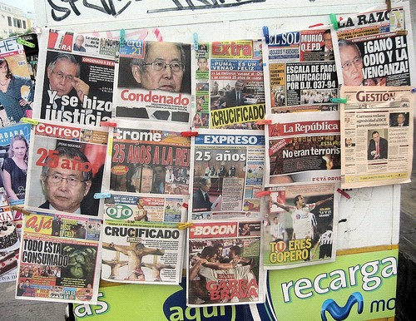When the scandal broke, Fujimori fled to Japan, where his parents were from. When he got there, he gave notice that he wanted to quit being President of Peru. Now Peru got a new president, who restored Peru’s government system. The new President brought criminal charges against Fujimori, accusing him of corruption, murder, and other acts against human rights.
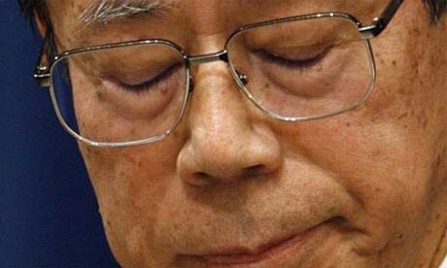

Fujimori after he resigned from his Presidency

Peruvian newspapers announcing
Fujimori’s sentence
After five years of hiding in Japan, Fujimori returned to South America. He was sent back to Peru, where he was put on trial for the crimes he committed while he was President. He was convicted of abusing his power and abusing peoples’ human rights. For this, he was sentenced to 31 years in prison. Even so, many people in Peru still supported him. When the court announced his sentence, riots broke out.

President Fujimori Worksheet
Mark it up. Look back through the reading and complete the following steps:

1. Underline the things that were in place to keep the President in check in Peru

2. Circle the steps that President Fujimori took to get rid of those checks

3. Draw a rectangle around the bad things that can happen if a Presidency has no checks

Sequence. Number the following items in order from 1 to 8.

A. Fujimori is successful at fighting the economic problems and terrorism in Peru.

B. President Fujimori tries to solve the economic crisis, but runs into too many obstacles.

C. Former President Alberto Fujimori is serving a 31 year sentence.

D. Fujimori dissolves Congress and says the Constitution can be ignored.

E. President Fujimori flees to Japan, but he eventually returns to South America where he is tried and convicted of acts against humanity.

F. Fujimori is elected the president of Peru.

G. Fujimori uses tanks and tear gas to stop Congress from meeting.

H. Scandal breaks out when people learn what Fujimori has done.

Weigh it out. What were the positives of total control? What are the negatives? Fill in the boxes below to
help you decide which side is more important.

Positive: Give one reason that President Fujimori was successful when he had total control:
Negative: Give two bad things that happened because President Fujimori had total control:

1)

2)

What do you think? Is it more negative or positive for the president to have total control? Will one side always outweigh the other or is it possible that it could go the other way?

Limits to Government. Read each scenario about a fictional country. Then highlight or underline each limit that applies in that country.

In the country of Balmbak, the men of the country are getting excited about the upcoming elections. Women are also allowed to vote this year, although their right to vote is not protected by Balmbak’s constitution. The constitution guarantees elections every 3 years, and these elections always happen. The constitution also says that certain laws do not apply to the country’s leaders.

Which of the following are in place to limit the government of Balmbak?

❑ Constitution  Rule of Law  Minority Rights  Consent of the Governed  Separation of Power

Samaland has a king and two other branches of government. Samaland’s constitution says the two branches can check the king’s power; however, it also says the king is above the law. The king is not elected, and he does not really care what his people think about him. Even so, the judicial branch of government works to protect the
even the least powerful citizens from being abused by the king.

Which of the following are in place to limit the government of Samaland?

❑ Constitution  Rule of Law  Minority Rights  Consent of the Governed  Separation of Power

Lilidian is a country with no constitution. The President of Lilidan created six branches of government. Responsibilities are distributed among these six branches, and the branches can limit each other’s power. Lilidian has no document to guarantee the rights of its citizens, but one of the branches does pass laws that are followed by everyone in the country, including government officials.

Which of the following are in place to limit the government of Lilidian?

❑ Constitution  Rule of Law  Minority Rights  Consent of the Governed  Separation of Power

What do you think? Fill in the boxes below. Take this opportunity to express your opinion!

Rank the limits of government in order from 1 (best at limiting gov- ernment) to 5 (worst at limiting government).

Constitution

Rule of Law

Minority Rights

Consent of Governed

Separation of Power
Give one reason that you picked your number one limit to govern- ment:
Do you think that government should be limited?  Yes  No

Why do you think that?

