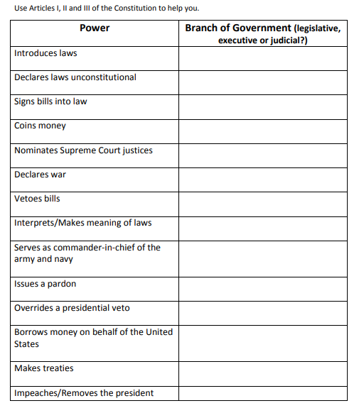
https://constitutioncenter.org/media/files/constitution.pdf

