THE BLIND MEN AND THE ELEPHANT
John Godfrey Saxe (1816-1887)’s version of the famous Indian legend

Indostan- old name for northern India  To learning much inclined – very interested in learning  spake- old-fashioned past tense of speak  quoth- said  E’en- even  grope- search by feeling  Disputed- argued  Exceeding stiff and strong- going beyond just being stubborn  oft- often  theologic- religious  disputants- those involved in the argument  I ween- I believe  rail on- complain bitterly  prate- chatter at length about nothing really important | 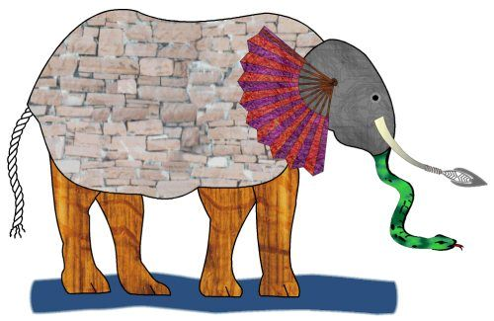  It was six men of Indostan,  To learning much inclined,  Who went to see the Elephant  (Though all of them were blind),  That each by observation  Might satisfy his mind.  The First approach'd the Elephant,  And happening to fall  Against his broad and sturdy side,  At once began to bawl:  "God bless me! but the Elephant  Is very like a wall!"  The Second, feeling of the tusk,  Cried, -"Ho! what have we here  So very round and smooth and sharp?  To me 'tis mighty clear,  This wonder of an Elephant  Is very like a spear!"  The Third approach'd the animal,  And happening to take  The squirming trunk within his hands,  Thus boldly up and spake:  "I see," -quoth he- "the Elephant  Is very like a snake!"  The Fourth reached out an eager hand,  And felt about the knee:  "What most this wondrous beast is like  Is mighty plain," -quoth he,-  "'Tis clear enough the Elephant  Is very like a tree!"  The Fifth, who chanced to touch the ear,  Said- "E'en the blindest man  Can tell what this resembles most;  Deny the fact who can,  This marvel of an Elephant  Is very like a fan!"  The Sixth no sooner had begun  About the beast to grope,  Then, seizing on the swinging tail  That fell within his scope,  "I see," -quoth he,- "the Elephant  Is very like a rope!"  And so these men of Indostan  Disputed loud and long,  Each in his own opinion  Exceeding stiff and strong,  Though each was partly in the right,  And all were in the wrong!  MORAL,  So, oft in theologic wars  The disputants, I ween,  Rail on in utter ignorance  Of what each other mean;  And prate about an Elephant  Not one of them has seen!

